## Chapter 2.1 The Storage Level

***Introduction:***

In this chapter, we do some research on the Storage Level about Computer System. The emphasis is put on the Introduction of Disk.

### Chapter 2.1.1 The Storage Level

***Introduction:***

One typical Computer System contains several different parts that can store the data. The price of these parts are different, but the changing range is small. As the changing of the Storage, the cheapest one and the most expensive one may have the 3 times difference. No need to weird that the most quickest access one will have the most expensive price.

***Level Structure:***

Describe level structure from the lowest to the fastest one:

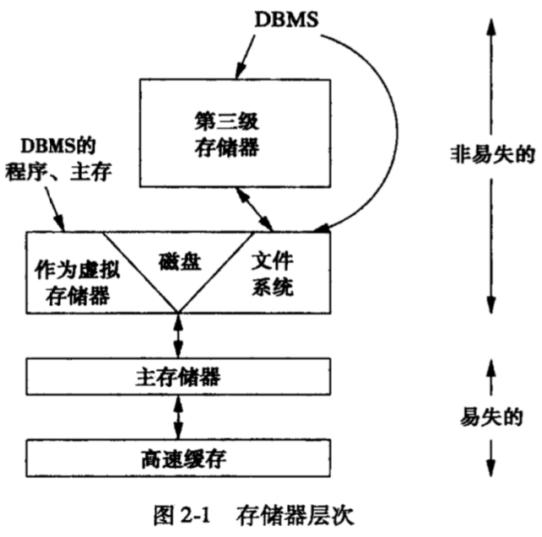

1. ***Cache (高速缓存)***

On - board cache is located on the microprocessor while the attached Secondary cache is located on another chip.

When the processor needs data and command, they will be moved from main memory to the cache, it only takes several nano - seconds to access the data in Cache.

1. ***Main Memory (主存)***

Computer main memory is the activity center of computer. No matter the operating of command or data manipulating, they all need to operate on the main memory message. Move the data from main memory to processor or cache, the range of speed is between 10 - 100 ns.

1. ***Secondary Storage (辅助存储器)***

The typical storage is disk. Transmit one byte from disk to main memory needs nearly 10ms.

1. ***Tertiary Storage (第三级存储器)***

Sometimes the storage of database system may exceed one single machine or multi - machines. In order to adapt such requirement, then tertiary storage has been developed in order to save terabyte data.

*Characteristic:*

Compared with the storage, its read and write time takes longer, but its capacity is much more than disk, so each byte costs less than disk.

### Chapter 2.1.2 Transfer Data Through the Level of Storage

***Principle:***

Normally, data transfers between the neighborhood level. When we need data, the access of each level will be organized in order to transfer large dataset to the lower level.

***Concept:***

* The disk is divided as the disk blocks (blocks, or pages), each size of the block is 4 - 64kb.
* The whole block moves out and moves into the continuous memory area named as the buffer block.
* High speed cache is the main basic unit of the main transfer between the main memory and high speed cache, normally is 32 continuous bytes.

***Key Point:***

The key point to speed the database operation is to arrange the data in the best way. When data of some disk block has been visited, then other data of this block may also need to be visited.

### Chapter 2.1.3 Volatile Memory and Non - Volatile Memory

***Concept:***

* Volatile Memory: When the power is cut off, then the volatile memory will lose all information.
* Non - Volatile Memory: When the power is cut off or the setting is shut down, then the Non - Volatile Memory will not lose data.

*(Since any changes on the database will not be considered as effective at last, until the changes have been stored into the Non - Volatile Memory.)*

### Chapter 2.1.4 Virtual Storage

Concept:

* Virtual Storage is an Address Space, its size is normally 32 bit, just say there has 2 ^ 32B or 4GB in the Virtual Storage.
* Operating System controls the Virtual Storage, and part of it leave in the main memory while the left part is saved in the disk.
* The data transfer through main memory and disk is mainly disk block or disk page.

*(More interests are placed on the Main Memory Database System, since it manage the data through Virtual Storage. Operating System uses the Page Mechanism to bring the real data into main memory. When the volume of data is small enough then it will be most useful.)*